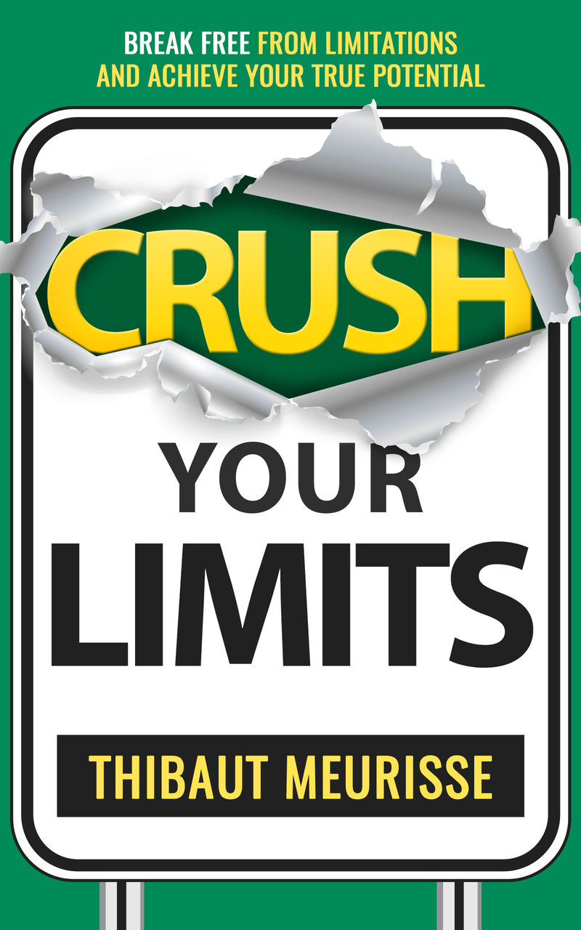**Crush Your Limits**

**Action Guide**

Thanks again for purchasing my book. I really want you to succeed and to get as much as you can from it. Please make sure you use this action guide alongside the book. In the end, your commitment is what will determine how much you get out of this book. I encourage you to print out this guide to make it easier to refer to it as you are reading the book. Also, writing down your answers using a pen is more powerful than just typing on your computer.

Let’s get started!

**Part I. Understanding assumptions**

**What are your specific assumptions?**

Complete the following sentences with whatever comes to your mind. Write as many answers as you like.

• Life is

• Success is

• Emotions are

• I am

• Money is

• Time is

• Work is

**Part II. Uncovering common assumptions**

**Negative assumption #1 - I’m convinced of something, therefore, it must be true**

**Exercise:** Write down your major assumptions. These are the core beliefs you’re most strongly attached to. Start opening yourself up to the possibility they may not be true.

-

-

-

-

-

**Negative assumption #2 - My beliefs need to be accurate**

**Exercise:** Select two or three empowering beliefs that would make the biggest difference in your life, if you were to adopt them.

Your assumptions:

-

-

-

**Life assumptions**

**Negative assumption #3 - Life is hard**

**Exercise:** write down all the reasons why your life is easy. Come up with at least twenty reasons. For instance, life is easy because:

* There is food on the table every day
* I have access to water and electricity
* I have great friends I can meet regularly
* I have access to great information online for free or at an affordable price.

-

-

-

-

-

-

-

-

-

-

-

-

-

-

-

-

-

-

-

-

-

-

**Negative assumption #4 - Other are happier than me**

**Exercise**:Answer the question: why am I probably as happy as anybody else?

-

-

-

-

-

-

-

-

-

**Negative assumption #5 - I’m the product of my environment**

**Exercise:**What could you do to change (and change your environment)? Come up with a couple of simple things you could do to start changing your life.

-

-

**Negative assumption #6 - I need to be realistic**

**Exercise:**Answer the following question: in what way are you holding back your potential due to the limitations imposed on you by others?

**Negative assumption #7 - If I received more, I would give more**

**Exercise:** What is one thing you could give more of?

**Negative assumption #8 - Having (too many) problems is a problem**

**Exercise:** Make a list of all your problems. How could you reframe them, so they become less of a problem, or even have them open doors to new opportunities?

Problem #1:

New interpretation:

Problem #2:

New interpretation:

Problem #3:

New interpretation:

Problem #4:

New interpretation:

Problem #5:

New interpretation:

**Negative assumption #9 - Things ‘should’ be a certain way**

**Exercise:**Make a list of five things you believe should be a certainty but aren’t right now. Then, replace “should” by “could”. How does it make you feel?

-

-

-

-

-

**Negative assumption #10 - My past equals my future**

**Exercise:** Close your eyes and imagine you could start your day free of any burden from the past. How would it make you feel?

**Negative assumption #11 - I’m not good enough**

**Exercise:** Look at one area in which you tend to blame yourself for not being good enough. Now, say to yourself, “I’m good enough for now.” Then, take a step back and put things in perspective. Realize how much room you have to improve and how much time you have to do so. You’re good enough *for now*. You can always improve yourself in the future if needed.

**Negative assumption #12 - I will believe it when I see it**

**Exercise:**Think of one thing you really want to make happen in the future. Hold the space for it. Make it part of your field of possibilities. Ask yourself:

What if I could create it?

What if it is possible?

**Negative assumption #13 - I’m not ready yet**

**Exercise:**Identify one thing you haven’t done (yet) because it makes you feel a little uncomfortable. Hold the space for it to happen in the near future.

Could you do it?

Will you?

**Negative assumption #14 - If I believe it, I can achieve it**

**Exercise:** Think of one thing you believe is impossible. It could be something you want to ask for or something you want to do. Could you challenge yourself to do it? Will you?

**Negative assumption #15 - It’s just who I am**

**Exercise**:What disempowering story have you been telling yourself for years? What if the opposite is true? Come up with twenty reasons why this story may not be true.

Your disempowering story:

Why it may not be true:

-

-

-

-

-

-

-

-

-

-

-

-

-

-

-

-

-

-

-

-

**Negative assumption #16 - I lack motivation/I’m lazy**

**Exercise:** Look at one area of your life in which you lack motivation. Now, try to identify why that’s the case. Is it because you have no interest? Is it because it isn’t aligned with your deepest values?

**Negative assumption #17 - Self-discipline sucks**

**Exercise:** Imagine if you could do all the things you know you should be doing. How would you feel? What difference would it make to your life? What single habit could help you build self-discipline?

My single habit:

**Negative assumption #18 - It’s selfish to focus on myself**

**Exercise:**Identify one quality that, if you were to develop, would have a positive impact on people around you. It could be keeping better control over your anger, keeping your promises, becoming a better listener, stopping criticizing people, etc.

One quality I could develop:

**Negative assumption #19 - I’m too old**

**Exercise:** Have you ever told yourself you’re too old to pursue your goals? If so, identify one goal you talked yourself out of because you considered yourself too old. Go to your favorite search engine and search for ‘old’ people who have accomplished that same goal. For instance, search ‘oldest people’ + your goal.

**Negative assumption #20 - Telling the truth hurts people and should be avoided**

**Exercise:** If you could tell only one truth you haven’t told before. Who would be the person you would tell it to and what would that be?

My one truth:

**Assumptions about success**

**Negative assumption #21 - Success is possible**

**Exercise**: Look at your biggest goal or dream. Now, imagine you were absolutely convinced success was inevitable. How would this make you feel? What action(s) would you take? Spend a couple of minutes playing that scenario in your mind.

**Negative assumption #22 - Success is having more**

**Exercise:** Look at the bigger vision you have for yourself. Now, write down all the qualities and skills the future you would embody.

Qualities:

Skills:

**Negative assumption #23 - Success is an outcome**

**Exercise:** Based on your current goals, write down your ideal successful day—what you would need to do to feel like a success every day. Select a few simple habits that move you toward this goal. Start with tiny daily goals and achieve them for thirty days. This will help you build more confidence and increase your self-esteem.

Simple habits you could adopt to achieve your goals:

-

-

-

-

**Negative assumption #24 - Failure is the opposite of success**

**Exercise:** Clear your mind and connect with your deepest sense of self. Now, realize that none of the ‘failures’ from your past have ever done anything to you. And no failure will ever. This is a very powerful realization.

**Negative assumption #25 - I’m either a success or a failure**

**Exercise:** Select one goal you have failed to achieve. Focus on what you did well. What progress did you make? What did you learn? What could you acknowledge about yourself? Was your intent pure?

**Negative assumption #26 - I need to be lucky to be successful**

**Exercise:** Imagine there is no such thing as luck and you are guaranteed to achieve anything you want. What would you do?

**Negative assumption #27 - I’m not there yet**

**Exercise:** Imagine there was nowhere else to go, nothing more to do to make you happy and complete. You could just release all the tension for one moment. How would it make you feel?

**Negative assumption #28 - I need to achieve big things to feel like I’m a success**

**Exercise:**Who did you help? Make a list of the people you helped in your life. Now, allow yourself to feel good for having help these people.

-

-

-

-

-

-

-

-

**Negative assumption #29 - I don’t have enough**

**Exercise:** Visualize all the things you ate today. Then, visualize some of your favorite dishes. Realize how blessed you are to have access to such a variety of dishes. Now, visualize yourself in the comfort of your bed. If you wish, you can do this exercise every day in the morning and/or in the evening.

**Negative assumption #30 - You can’t have it all**

**Exercise:** Visualize what it would look like if you had it all (whatever that means to you). Keep that vision as a possible future. Hold the space for it in your mind.

**Negative assumption #31 - I can’t ask for what I want**

**Exercise:** Write down the top three things you wanted to ask but didn’t. Ask yourself, what if I could ask these things?

-

-

-

**Negative assumption #32 - I already know that**

**Exercise:** Write down ten things you believe you know but actually don’t, i.e. things you know intellectually but haven’t actually applied in your life. The easiest way to do this is to look at results you’re after but haven’t been able to produce (yet).

-

-

-

-

-

-

-

-

**Negative assumption #33 - I’ve reached a plateau and can’t improve anymore**

**Exercise:** Identify an area in which you feel stuck or fail to get the results you want. Ask yourself, what can I do to get unstuck?

**Assumptions about money**

**Negative assumption #34 - Money is not important**

**Exercise:** Answer the following questions with brutal honesty:

• If you had enough money to never have to work again, would you still be working at your current job?

• Do you often think about money? (Worrying, fantasizing about making more money etc.) What does this say about your relationship with money?

• Would you change your life drastically as a result of having more money in your bank account? If so, how?

Now, based on your answers, how important is money to you?

**Negative assumption #35 - Money is the root of all evil**

**Exercise:** What is one small action I could take to change my relationship with money and extend my comfort zone? (E.G. give money to charity, invest in myself, charge more for my services, etc.)

My small action:

**Negative assumption #36 - Being poor is noble**

**Exercise:** Spend a few seconds to write down the values you give to money, whatever they may be.

**Negative assumption #37 - Money is scarce**

**Exercise:** Take a few seconds to meditate on the fact that money isn’t something external you need to earn or attract. It comes from within you as one manifestation of wealth.

**Negative assumption #38 - Money doesn’t grow on trees**

**Exercise**:Write down twenty ways you could attract more money in your life.

-

-

-

-

-

-

-

-

-

-

-

-

-

-

-

-

-

-

-

-

**Negative assumption #39 - Wealth equals money**

**Exercise:**How resourceful are you? Write down all the qualities and strengths you have and could rely on to attract the resources you need to create wealth. This could be your motivation, passion, creativity, etc.

**Assumptions about emotions**

**Negative assumption #40 - I am my emotions**

**Exercise:** Remember one of the worst things that ever happened to you. Now, notice how it has passed.

**Negative assumption #41 - My emotions dictate my actions**

**Exercise:**Knowing you dictate your actions, not your emotions, what will you start doing differently from now? What will you do whether you feel like it or not?

**Negative assumption #42 - I get upset because of something external**

**Exercise:** Select something that upset you recently. Look at what happened objectively without adding your interpretation to the event. Notice how the issue probably isn’t the event itself, but the story you’ve attached to it.

**Negative assumption #43 - I’m responsible for how other people feel**

**Exercise:**Write down one situation where worrying about how others may feel prevents you from doing something you really want to do.

**Negative assumption #44 - Complaining is natural**

**Exercise:** For one full day, refuse to complain about anything. If you want, you can extend this challenge for as long as you like. A great book to read on the topic is Will Bowen’s, *A Complaint Free World: How to Stop Complaining and Start Enjoying the Life You Always Wanted.*

**Assumptions about work**

**Negative assumption #45 - I can’t find a job I love**

**Exercise:** What does your ideal job look like? Write it down.

**Negative assumption #46 - I can’t make money doing what I love**

**Exercise:** Write down twenty ideas on how you could make money doing what you love.

-

-

-

-

-

-

-

-

-

-

-

-

-

-

-

-

-

-

-

-

**Negative assumption #47 - I have to work forty plus years and retire at sixty-five**

**Exercise:** Where would you like to be professionally in five years? Write down what your ideal career would look like.

My ideal career:

**Negative assumption #48 - I work hard now so I can enjoy my life once I finally retire**

**Exercise:** answer the following question: Assuming I could never retire and had to work until the day I die, would I still be doing what I’m currently doing?

**Assumption about time**

Time is one of the most important resources we have. In this section, we’ll cover two major assumptions that could prevent you from making the most of your time.

**Negative assumption #49 - I don’t have enough time**

**Exercise:** For an entire week, write down every activity you do at work and at home. Now, look at all your tasks. Which ones are really productive? Do you really not have time to strive for your goal in life?

**Negative assumption #50 - Money is more valuable than time**

**Exercise:** Write down all the tasks you could stop doing because they aren’t aligned with your vision or aren’t productive.

**Part III. Creating new assumptions**

**Selecting your core life assumptions**

Let’s start by unearthing your major assumptions about life.

We introduced the following assumptions earlier:

*• Life is easy. And I do whatever I can to keep it this way.*

*• I’m as happy as anybody else.*

*• As I change, my environment changes.*

*• I create my own reality. What others believe I can or cannot do is irrelevant.*

*• By giving more, I open myself to receiving more.*

***•*** *Having problems is normal. The less attached I am to them, the more irrelevant they become.*

*• In any problem lies opportunity.*

*• I fully accept what is, and I can create what will be.*

*• Every day I start anew, free of any burden from the past.*

*• I’m good enough for now.*

*• I’m perfect in my imperfections.*

*• My intent is pure.*

*• I matter.*

*• I believe it, and therefore I’ll see it.*

*• Because I start before I’m ready, I can achieve anything I want faster than I ever thought possible.*

*• I ask for whatever I want, regardless of how I feel.*

*• I’m the scriptwriter of my life, and I can rewrite my story at will.*

*• I’m motivated because I have a motive for action.*

***•*** *Self-discipline equals freedom. With enough self-discipline, I can achieve anything I want.*

***•*** *I take care of me for my family and friends.*

***•*** *I’m never too old to do what I want to do*

*• I help others and myself grow by telling the truth whenever possible.*

To begin with select only five assumptions in this list. If you were to adopt them, what five assumptions would make the biggest difference in your life?

-

-

-

-

-

**Selecting assumptions in major areas of your life**

Now you have selected your top five life assumptions, let’s look at some major assumptions you could adopt in various areas of your life.

Below is a summary of the assumptions we introduced previously:

**Success**

*• Success is inevitable.*

*• Success is not about what I have, it’s about who I become.*

*• I happily fail my way to success. I fail faster and better each time.*

*• I’m successful because I’m making progress toward my goal.*

*• I create my own success regardless of external circumstances.*

*• I’m already there, and I’m more than enough for now.*

*• By having changed some people’s lives, even in a minor way, I’m already a huge success.*

*• I have good intentions, therefore I’m a massive success.*

*• Food + shelter = happiness + success*

*• I can have it all.*

*• I allow myself to ask for what I want.*

*• If I don’t live it, I don’t know it.*

*• Everything is learnable, and I can always improve.*

**Money**

• *Money is important.*

*• I give myself total permission to give and receive money in abundance.*

*• The more money I have, the more people I can help.*

*• Wealth is unlimited, and I can always create more of it.*

*• Wealth creation is inevitable, I just have to plant the right seeds.*

*• I’m the source of wealth. I have enough resourcefulness to attract any resources I need to create wealth.*

**Emotions**

• *Emotions come and go. What I am, remains untouched. Forever.*

*• I dictate my actions, regardless of the way I feel.*

*• Nothing outside of me has the power to upset me.*

*• I’m responsible for how I feel, not for how other people feel.*

*• I refuse to complain. I do something about it or I accept it.*

**Work**

*• I can find a job I love, and I will!*

*• I can absolutely make money doing what I love.*

*• I have the power to design my career the way I want to.*

*• I proactively design a career I love and enjoy my life now.*

**Time**

*• I make the time to do whatever I’m committed to doing.*

*• I value my time because I value myself.*

Now, let’s see how you can start creating a new identity by using some of these empowering assumptions.

**Creating your Identity Map**

Create branches for each area in which you want to implement new empowering assumptions. Remember, this is all about *you* and the life you want to create for *yourself*. Start with the questions: Who do I want to become? If I were to adopt them, what new empowering assumptions would allow me to be that person?

**My Best Self**

**Creating reminders**

Now you have your Identity Map, put it somewhere you can see it every day. I recommend you put it on your wall, on your desk and/or in a notebook you carry with you.

**Your 30-Day Challenge**

Dedicate the next thirty days to implementing new and empowering assumptions. Go through the process summarized below.

**Step-by-step method to creating your new identity**

**• Create an *Identity Map***

⁃ Select your core life assumptions.

⁃ Select assumptions in each area of your life.

**• Repeat your assumptions each day** for at least ten minutes, (five minutes in the morning, five minutes in the evening). Follow the process below:

⁃ Repeat your assumptions, (in your mind or out loud),

⁃ Ask yourself why it is true.

⁃ Energize your assumptions by engaging your emotions.

⁃ Envision the concrete actions you can take.

**• Check how you feel.** If you feel resistance, work through it.

⁃ Identify where you feel the emotion in your body.

⁃ Stay present with it until it starts dissolving. Focus on the most intense part of the emotion.

⁃ Repeat this process as many times as necessary for the fear to dissipate.

**• Create reminders**

⁃ Put your mind map on your wall, desk and/or in a notebook you carry with you.

⁃ Write down your assumptions on flashcards and review them several times each day.

**Asking “What if?”**

An effective way to stretch yourself beyond your comfort zone is to look at each of the following areas of your life and ask yourself, “*What if*?”

• Career

• Family/friends

• Finance

• Health/fitness

• Relationship

• Personal growth

Answer the following questions.

**Career**

What if I could have the perfect career?

**Family/friends**

What if I could experience and share more joy than I ever have with my family and friends?

**Finance**

What if I could double my income by the end of the year?

**Health/fitness**

What if I could have lots of energy and feel great every day?

**Personal growth**

What if I could overcome my fears and grow beyond my imagination?

**Relationship**

What if I could take my relationship to a whole new level?

Visualize what your life would look like in each of the above situations.

**Going beyond your realm of possibility**

Stretch yourself further by answering the following questions. Feel free to come up with your own questions.

**Career**

What if I could have the perfect career in exactly the way I want it?

What if I could change my career within twelve months? Six months? One month?

What if I could change my career this week?

**Family/friends**

What if I could experience ridiculous levels of bliss and joy in presence of my family and friends? What if I could feel total gratitude for every person who ever showed up in my life?

**Finance**

What if I could double my income within a year? Within six months? Within thirty days?

What if I could generate ten times my income within a year?

**Health/fitness**

What if the level of joy I’ve experienced so far is just a fraction of the level my real self can experience?

What if I could experience intense feelings of bliss as never before?

**Personal growth**

What if I’m currently just a tiny fraction of the person I could be?

What if I’m just scratching the surface of what is possible for me in this world?

What if I could remove any fear, self-about and limitations in any area of my life and move freely in this world?

**Relationship**

What if I could take my relationship to a whole new level and one I didn’t even know exist?

**Committing to the impossible**

Let’s take this exercise one step further. For each area, ask yourself, “If I had to achieve this crazy vision, what would I do?”

Play along and imagine you had to achieve your goals at all cost. Force yourself to think in a way you’ve never thought before.

**THANK YOU SO MUCH!**

I hope you enjoyed this book and that you’ll keep raising your standards and demanding more of yourself in the coming years.

Let me wish you all the best with all your new endeavors. I’m very much looking forward to hearing from you on my website.

If you have any questions send me an email at [thibaut.meurisse@gmail.com](mailto:thibaut.meurisse@gmail.com)

* To connect with me join my Facebook page [here](https://www.facebook.com/whatispersonaldevelopment.org/)
* To follow me on Youtube click [here](https://www.youtube.com/channel/UCyxE5waVyUmJguJQbHSqCyg?view_as=subscriber)
* To check out my author page click [here](http://www.apple.com)

Thanks a lot

Thibaut Meurisse

Founder of [Whatispersonadevelopment.org](http://whatispersonaldevelopment.org/)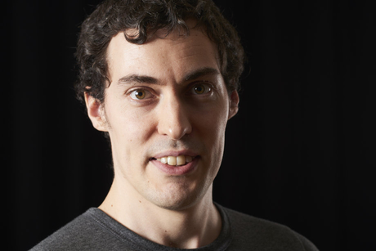

**Other books by the author:**

[Goal Setting: The Ultimate Guide to Achieving Goals That Truly Excite You](http://myBook.to/goalsetting)

[Habits That Stick: The Ultimate Guide to Building Powerful Habits That Stick Once And For All](http://myBook.to/Habits-that-stick)

[Master Your Emotions: A Practical Guide to Overcome Negative and Better Manage Your Feelings](http://mybook.to/Master_Emotions)

[Productivity Beast: An Unconventional Guide to Getting Things Done](http://mybook.to/productivitybeast)

[The Greatness Manifesto: Overcome Your Fear and Go After What You Really Want](http://mybook.to/greatnessmanifesto)

[The One Goal: Master the Art of Goal Setting, Win Your Inner Battles, and Achieve Exceptional Results](http://myBook.to/theonegoal)

[The Thriving Introvert: Embrace the Gift of Introversion and Live the Life You Were Meant to Live](http://myBook.to/introvert)

[The Passion Manifesto: Escape the Rat Race, Uncover Your Passion and Design a Career and Live You Love](http://mybook.to/passion_manifesto)

[Upgrade Yourself: Simple Strategies to Transform Your Mindset, Improve Your Habits and Change Your life](http://myBook.to/upgradeyourself)

[Wake Up Call: How to Take Control of Your Morning and Transform Your Life](http://myBook.to/Wake-up-call)

**Did you enjoy this book?**

If you benefit from this book, make sure to leave a review on Amazon. You could inspire other people like you to make changes in their lives as well. And that would mean so much to me!



Thank you for your support!!

Thibaut

